**DAILY ONLINE ACTIVITIES SUMMARY**

|  |  |  |  |  |  |  |  |  |
| --- | --- | --- | --- | --- | --- | --- | --- | --- |
| **Date:** | **09-06-2020** | | | | | **Name:** | **Shone K Sunny** | |
| **Sem & Sec** | **8 sem , A sec** | | | | | **USN:** | **4AL14CS081** | |
| **Online Test Summary** | | | | | | | | |
| **Subject** | | **BDA** | | | | | | |
| **Max. Marks** | | **30** | | **Score** | | | **27** | |
| **Certification Course Summary** | | | | | | | | |
| **Course** | **CloudEndure Migration Training- Technical** | | | | | | | |
| **Certificate Provider** | | | **AWS** | | **Duration** | | | 2hrs |
| **Coding Challenges** | | | | | | | | |
| **Problem Statement:** Function to print binary number using recursion | | | | | | | | |
| **Status: Competed** | | | | | | | | |
| **Uploaded the report in Github** | | | | | **yes** | | | |
| **If yes Repository name** | | | | | **shonekks** | | | |
| **Uploaded the report in slack** | | | | | **yes** | | | |

Online Test Details: (Attach the snapshot and briefly write the report for the same)

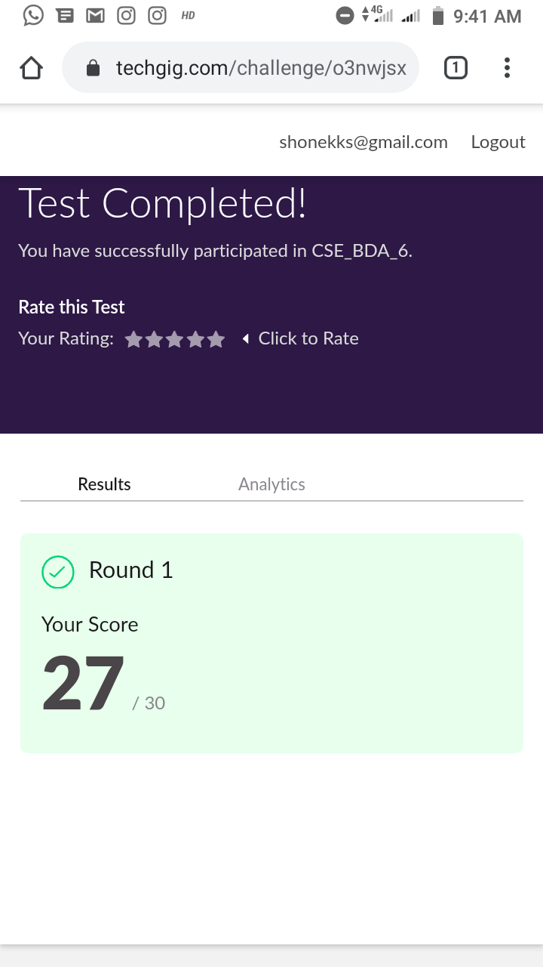

Certification Course Details: (Attach the snapshot and briefly write the report for the same)

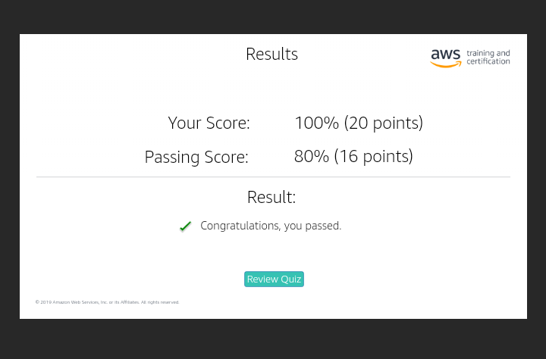

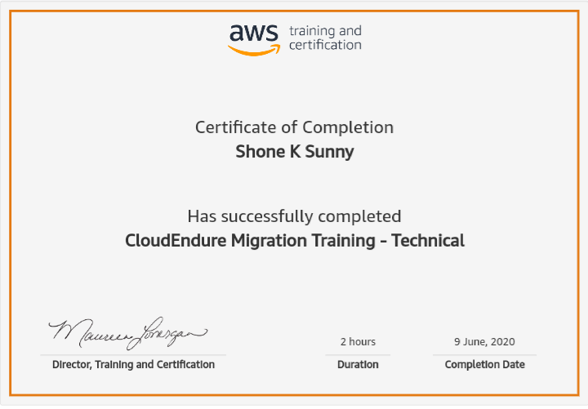

Coding Challenges Details: (Attach the snapshot and briefly write the report for the same)

Program-> Function to print binary number using recursion

def convertToBinary(n):

if n > 1:

convertToBinary(n//2)

print(n % 2,end = '')

dec = 34

convertToBinary(dec)

print()